MTF Research Summary
John N. Rogers, III, Ryan Bearss, Jackie Guevara, and Evan Rogers
Michigan State University
January 2026

Research background: Since initiating the FIFA World Cup 2026 research program in 2022, our work primarily focused on the establishment of sod on plastic (SOP), including both stabilized and non-stabilized systems. In 2025, this body of work was largely completed, and emphasis transitioned to post-installation management.

Study #2: Leveraging phosphorus limitations and microbial biostimulants for the establishment of non-sod forming turfgrass species over plastic

The objective of this experiment was to evaluate the effects of microbial biostimulants on the establishment, health, nutrient uptake, and rooting of Perennial ryegrass (Lolium perenne L.) sod grown on plastic establishment. The experiment was conducted from September 2024-June 2025. Perennial ryegrass (Lolium perenne L.) was seeded to 20 seeds in⁻² into 25 mm of USGA 90/10 (sand/peat). Treatments were fertilized with starter (49 kg N ha⁻¹ + 40 kg P ha⁻¹) or not, and at time of seeding, 1 month after seeding (MAS), and 8 MAS, were inoculated with or without Azospirillum brasilense, Rhizophagus irregularis, or both. Low rates of foliar N (7.3 kg ha⁻¹) were applied to all treatments biweekly. Plots were mown weekly to 25 mm.

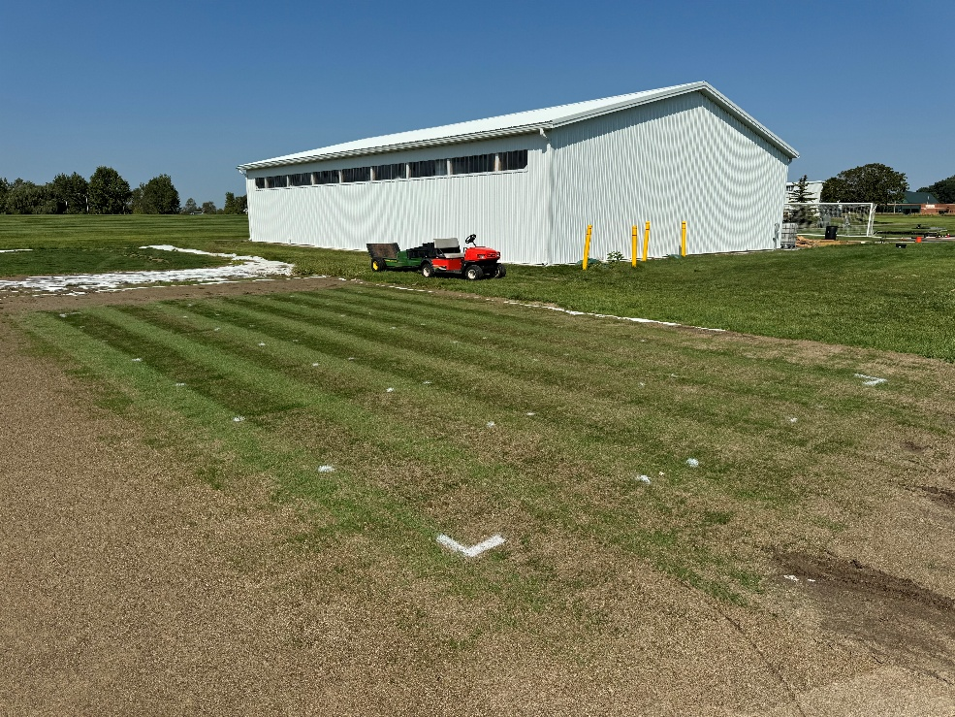
Figure 2. Microbial biostimulant experimental plots, 4 weeks after seeding (East Lansing, MI, 2024)

Key findings:
- Azospirillum brasilense and Rhizophagus irregularis did not improve Lolium perenne L. turfgrass cover or health during establishment.
- Non-fertilized R. irregularis and co-inoculated treatments produced the lowest mean root diameter and greatest proportion of fine roots (0-0.25 mm).
- Shoot phosphorus content in both co-inoculated treatments was ≈47% higher than non-fertilized individually inoculated treatments.
- Microbial biostimulants had minimal effects on sod establishment at the starter fertilizer rates and inoculation frequencies used in this trial

